Software Engineering UML

1. Here the AbstractHTMLView is an AbstractCalender, and it has access to the same functions. HTMLMonthlyView, HTMLCompactWeekView, and HTMLWeekView can all provide html using their immediate parent’s method, and any information contained in the actual calendar using AbstractCalender’s methods.

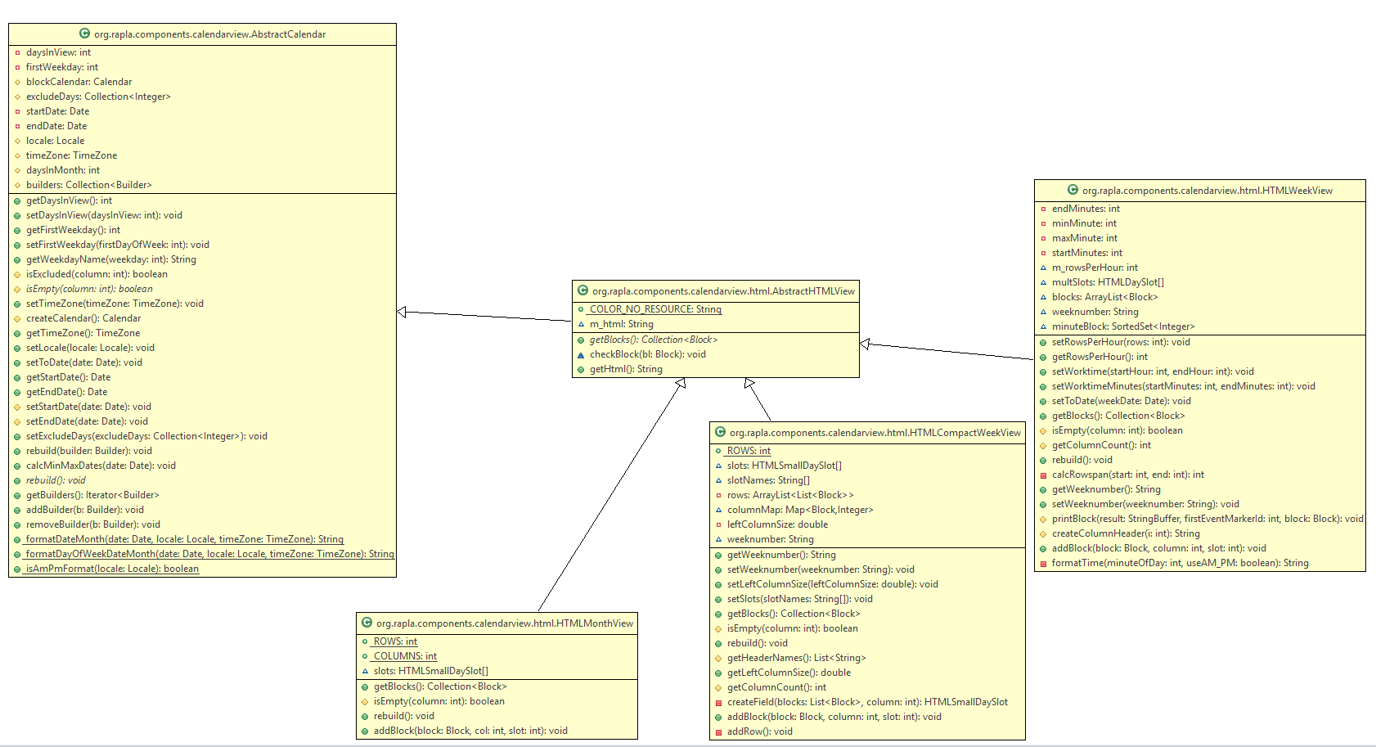

2. Whenever a RaplaTime instance is created, it invokes the TimeField constructor. RaplaTime takes a time and assigns it to a new event. RaplaTime gets the desired time by using TimeField to directly parse a user’s input into a format it knows how to handle.

